**CEFAS CefMAT Programme**

**Work Order Definition**

|  |  |
| --- | --- |
| **Title** | D1_LFI Large Fish Indicator |
| **Prepared by** | Joseph Ribeiro |
| **Date** | May 2018 |
| **Version** | Internal Draft |
| **Status** |  |

# Version History

| **Amended by** | **Description of change** | **Status** | **Date** |
| --- | --- | --- | --- |
| J Ribeiro | Document Created for internal review | V1 | 15/05/2018 |
|  |  |  |  |
|  |  |  |  |
|  |  |  |  |
|  |  |  |  |

# Approvals

# RACI Approvals

# R=Responsible, A=Accountable, C=Contributor, I=Information only

|  |  |  |  |  |
| --- | --- | --- | --- | --- |
| **RACI** | **Role** | **Name** | **Version approved** | **Date** |
| R | Cefas PI | Eva Garnacho |  |  |
| A | Cefas PMs / Sponsor | D Pettengell / W Dawson |  |  |
| C | Cefas Data Analyst | Joe Ribeiro |  |  |
| C | WP lead and Cefas Assessor | Chris Lynam |  |  |
| I | Cefas Developer Operations | Jane Atherton |  |  |

## Context

**Introduction**

This document describes the specification for updating the Large Fish Index in UK Fish Communities on CEFMAT. This indicator has already been developed by landmark using an old dataset, however it is our intention to update the data used in the assessment, and increase user functionality of the tool by providing landmark with an updated script used to produce it. This indicator is to be provided on a public page, available as a data product option in a drop-down list under the Fisheries Assessments category. The user will have options to choose how / where the assessment is applied.

A more detailed explanation of this indicator is available from the OSPAR website at [https://oap.OSPAR.org/en/OSPAR-assessments/intermediate-assessment-2017/biodiversity-status/fish-and-food-webs/proportion-large-fish-large-fish-index/](https://oap.ospar.org/en/ospar-assessments/intermediate-assessment-2017/biodiversity-status/fish-and-food-webs/proportion-large-fish-large-fish-index/).

The indicator should be publicly available, however a private version (for CEFAS employee use) should also be created. The public version should be titled “Large Fish Index” whilst the private version should be titled “Large Fish Index (PRIVATE)”. The public and private version should almost be identical, with the exception that the results from one survey are excluded from the analysis for the public version.

**Development requirements**

**INPUTS:**

The data for this length assessment is provided in a folder titled **LFI**. This folder must be kept as a package, as the files and folders are read by an r file which relies upon the other files in the package having specific names and being in a specific location relative to the main script “Lynam_IND_script_OSPAR_LFI.r”.

This script and output is very similar to other deliverables to be developed by Landmark: MML and TyL. A crucial difference here is that only demersal results are used: Pelagic results are not to be used for the LFI.

**Data sets**

* “LFI\Scripts_and_required_files\Data_Product_V3\Biological_Info” folder. Contains key biological data used in this assessment.
* “LFI\Scripts_and_required_files\Data_Product_V3\Sampling_Info” folder. Contains key sampling data pertaining to the origin of the biological data.
* “LFI\Scripts_and_required_files\Walker_GearEfficiency_ICESJMarSci17_Supp” folder. It is needed for this assessment to compare different surveys and species, as it contains additional information on the effectiveness of different fishing gears at catching different species.
* “LFI\Scripts_and_required_files\Strata” contains subfolders which define each survey region, and are used to map the results of this assessment.
* The r script “LFI\Scripts_and_required_files\Lynam_IND_script_OSPAR_LFI.r”. This reads all of the data provided above, and combines it with other functions to apply the assessment to the data and generate results that can be interpreted by the CEFMAT tool.
* The results generated by the script “LFI\Scripts_and_required_files\Lynam_IND_script_OSPAR_LFI.r” are stored in the “LFI\Outputs” folder. It is explained later how these results are to be interpreted.

Table a lists whether each survey belongs to the North Sea or the Celtic Sea where applicable. Surveys not listed here will not need to be assessed.

Table a: List of groundfish surveys, region in which they operate, and the period over which they have been undertaken. 1. Survey acronym convention: First 2 to 4 Capitalised letters indicate the MSFD subregion (BBIC – Bay of Biscay and Iberian Coast; CS – Celtic Seas; GNS – Greater North Sea; WA – Wider Atlantic). Next Capitalised and lower case letters signify the country involved (Fra – France; Eng – England; Ire – Republic of Ireland; NIr – Northern Ireland; Sco – Scotland; Ger – Germany; Net – The Netherlands; Int – International. International refers to the two international groundfish surveys carried out in the North Sea under the auspices of ICES. Next two capitalised letters indicate the type of survey (OT – Otter trawl; BT – Beam trawl). Final number indicates the season in which the survey is primarily undertaken (1 – January to March; 3 – July to September; 4 – October to December). 2 This is a single survey that operates across both the Celtic Seas and the Bay of Biscay subregions, from the southern coast of the Republic of Ireland and down the western Atlantic coast of France. For indicator assessment purposes this single survey was split into its two subregional components



|  |  |  |  |
| --- | --- | --- | --- |
| **Region** | **Survey Acronym** | **Applicable Start year** | **Final year available in the current dataset** |
| Celtic Seas (including OSPAR Wider Atlantic) | CSEngBT3 | 1993 | 2015 |
| CSIreOT4 | 2003 | 2015 |
| CSNIrOT1 | 1992 | 2015 |
| CSNIrOT4 | 1992 | 2015 |
| CSScoOT1 | 1985 | 2016 |
| CSScoOT4 | 1995 | 2015 |
| CSFraOT4 | 1997 | 2015 |
| WAScoOT3 | 1999 | 2015 |
| CSBBFraOT4 | 1997 | 2015 |
| Greater North Sea | GNSEngBT3 | 1990 | 2015 |
| GNSFraOT4 | 1988 | 2015 |
| GNSGerBT3 | 2002 | 2015 |
| GNSIntOT1 | 1983 | 2016 |
| GNSIntOT3 | 1998 | 2016 |
| GNSNetBT3 | 1999 | 2015 |

**Metadata**

Data under “LFI\Scripts_and_required_files\Data_Product_V3” has been modified from raw “exchange data” available from the ICES DATRAS data portal:

<https://datras.ices.dk/Data_products/Download/Download_Data_public.aspx>

The processed data supplied are known as the “Groundfish Survey Monitoring and Assessment Data Product for the Northeast Atlantic Area” and they are publicly available. Raw abundance data has been modified by first scaling any large and thus subsampled catches to the level of the complete haul and then dividing the species catch numbers-at-length by the area swept by the trawl on each sampling occasion (Greenstreet and Moriarty, 2017; Moriarty et al., 2017). Thus, the catch data have been converted to estimates of fish density-at-length, by species, at each sampling location in each year.

For more information on the origins of this data please see the relevant Marine Scotland website here:

<https://data.marine.gov.scot/dataset/manual-version-3-groundfish-survey-monitoring-and-assessment-data-product>

Metadata for the datasets used in this tool is provided in

LFI\MarScotV3_D4_metadata_April 2018.xlsx

**Field descriptions**

Metadata field description for this indicator should read as follows:

*“Fisheries survey data originating from the Database of Groundfish Surveys (DATRAS) was quality checked by Marine Scotland Science to produce the OSPAR data product. This raw assessment data is held by ICES and available through the ICES DATRAS portal: [hyperlink:https://datras.ices.dk/Data_products/Download/Download_Data_public.aspx]*

*Survey data have been aggregated by Marine Scotland Science into a Groundfish Survey Monitoring and Assessment Data Product. For further information on this data product please see the reference material here [hyperlink: https://data.marine.gov.scot/dataset/manual-version-3-groundfish-survey-monitoring-and-assessment-data-product]”*

*The following documents are of particular relevance:*

*Greenstreet, S.P.R and Moriarty, M. (2017) Manual for Version 3 of the Groundfish Survey Monitoring and Assessment Data Product. Scottish Marine and Freshwater Science Vol 8 No 18, 77pp. DOI: 10.7489/1986-1*

*Moriarty, M., Greenstreet, S.P.R. and Rasmussen, J. (2017) Derivation of Groundfish Survey Monitoring and Assessment Data Product for the Northeast Atlantic Area. Scottish Marine and Freshwater Science Vol 8 no 16, 240pp. DOI: 10.7489/1984-1*

*Results are presented by survey and can be displayed or omitted as required. Survey acronym convention is as follows: First 2 to 4 Capitalised letters indicate the MSFD subregion (BBIC – Bay of Biscay and Iberian Coast; CS – Celtic Seas; GNS – Greater North Sea; WA – Wider Atlantic). Next Capitalised and lower case letters signify the country involved (Fra – France; Eng – England; Ire – Republic of Ireland; NIr – Northern Ireland; Sco – Scotland; Ger – Germany; Net – The Netherlands; Int – International). International refers to the two international groundfish surveys carried out in the North Sea under the auspices of ICES. Next two capitalised letters indicate the type of survey (OT – Otter trawl; BT – Beam trawl). Final number indicates the season in which the survey is primarily undertaken (1 – January to March; 3 – July to September; 4 – October to December).*

*Beam trawl surveys are more efficient at catching benthic species such as sole and otter trawls have a greater chance of catching pelagic species such as mackerel, and results from such surveys are preferable should sufficient length samples be available. Differences in results by survey may also be reflective of the season in which they are conducted”*

Data processing field description

*“The Large Fish Indicator assessment reflects the proportion of the demersal fish and elasmobranch community that attain a large body size. Large individuals are defined as those longer than a survey-specific threshold length (40 cm in the North Sea IBTS) following the OSPAR EcoQO proportion of large fish description by Greenstreet et al (2011). In response to fishing pressure and other stresses, species with late maturity and a large ultimate body size often decline in abundance more rapidly than smaller and faster-growing species (Kirkwood et al., 1994). As such, simple indicators such as Maximum Length and the Large Fish Index can indicate the response to fishing pressure, but other stressors such as climate change will induce changes in LFI (Jennings et al., 1999; Queirós et al., 2018)*

*LFI calculations use estimates of fish biomass density-at-length provided by the first quarter (Q1) international bottom trawl survey. Greenstreet et al. (2011, 2012) first calculated the Large Fish Index (LFI) for the North Sea, using a threshold defining ‘large fish’ (LLF). The LFI is then calculated as:*

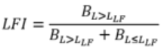

*where L is length (in cm) and B is biomass density (as kg/km2).*

*This tool assesses ICES groundfish survey data obtained through trawl surveys in the Celtic Sea and Greater North Sea since 1983. The main steps in the calculation of the LFI are: transforming sampled numbers of fish per unit area to estimates of biomass densities of fish units of kg/m2; raising sample level data to biomass densities in assessment areas, time series assessment against baseline and reference level. Time series are calculated from different surveys in different OSPAR areas. The calculation is detailed by Fung et al (2013) with the additional step of average haul densities by rectangle and sub-division (Greenstreet et al in prep.; ICES 2015). These data processing steps are elaborated upon in the following paragraphs.*

*Due to the variability in time/season, area and gear between surveys, data used in this assessment have been left un-aggregated and are instead presented as separate result outputs at the survey level. In order to be accurate and meaningful, the indicator requires that surveys are conducted at regular intervals (e.g. annually) in the same area with a standard fishing gear targeting the same species assemblage.*

*Standard data collected on these surveys consists of numbers of each species of fish sampled in each sample, measured to defined length categories (i.e. 1cm below, so a fish with a recorded length of 14 cm would be between 14.00 cm* *and 14.99 cm in length). By dividing these species catch numbers-at-length by the area swept by the trawl on each sampling occasion, these catch data are converted to standardised estimates of fish density-at-length, by species, at each sampling location. However, the indicator is based on biomass rather than abundance, so these abundance densities were converted to biomass density data through the application of species weight (w) at length relationships (of the form w = aLb, where a and b are species-specific parameters). Density estimates per length category per species based on biomass (kg per km2) are referred to below as Catch Per Unit Area (CPUA).*

*These trawl-sample density-at-length estimates were averaged (retaining year, species and length category information) across all trawl samples within each sampling stratum (i.e. survey specific strata following the survey design, which is a rectangular grid in the North Sea and generally depth-based strata elsewhere).*

*The lack of data prior to large scale commercial fishing, means it is difficult to determine what LFI values have been indicative of sustainable populations of demersal and pelagic fish. The time-series of data for most areas assessed, started in the 1980s or 1990s when fishing pressure had been high for a number of years. For the UK target to be met, LFI would be expected to be increasing compared to earlier points in the time-series.*

*LFI trend assessments on this webpage use breakpoint analysis, and any improvement or reduction in the LFI mapped here is indicative of this analysis. An improvement is defined here as a period of lower mean LFI, followed by a terminal period of higher mean LFI as identified by breakpoint analysis, whilst a reduction is defined as a period of higher mean LFI, followed by a terminal period of lower mean LFI. Loess lines on figures are produced using the loess function in the r stats package, with a 10 year span and a 2nd degree polynomial. Breakpoints were identified using the r breakpoints function with a minimal segment size of 3. Please note that in the future there might be regional modifications to the methodology.*

*References:*

*Fraser, H. M., Greenstreet, S. P. R., and Piet, G. J. 2007. Taking account of catchability in groundfish survey trawls: implications for estimating demersal fish biomass. ICES Journal of Marine Science, 64: 1800–1819*

*Fung, T., Farnsworth, K. D., Shephard, S., Reid, D. G., and Rossberg, A. G. 2013. Why the size structure of marine communities can require decades to recover from fishing. Marine Ecology Progress Series, 484, 155—171. doi:10.3354/meps10305.*

*ICES. 2015. Report of the Working Group on Biodiversity Science (WGBIODIV), 9–13 February 2015, ICES Headquarters, Copenhagen, Denmark. ICES CM 2015/SSGEPD:04.*

*Greenstreet, S. P. R., Rogers, S. I., Rice, J. C., Piet, G. J., Guirey, E. J., Fraser, H. M., and Fryer, R. J. 2011.  
Development of the EcoQO for the North Sea fish community. – ICES Journal of Marine Science, 68: 1–11*

*Jennings, S., Greenstreet, S. P. R., and Reynolds, J. D. 1999. Structural change in an exploited fish community: a consequence of differential fishing effects on species with contrasting life histories. Journal of Animal Ecology, 68: 617-627.*

*Kirkwood, G.P., Beddington, J.R., Rossouw, J.A. 1994 Harvesting species of different lifespans. Large-Scale Ecology and Conservation Biology (eds P. J.Edwards, R. M.May & N. R.Webb), pp. 199 227. Blackwell Science Limited, Oxford.*

*Lynam C.P. and A.G. Rossberg. (2017) New univariate characterization of fish community size structure improves precision beyound the Large Fish Indicator. Available: at arXiv:1707.06569*

*Shephard, S., Fung, T., Houle, J. E., Farnsworth, K. D., Reid, D. G., and Rossberg, A. G. 2012. Size-selective fishing drives species composition in the Celtic Sea. ICES Journal of Marine Science, 69: 223–234.”*

*Queirós, A. M., Fernandes, J., Genevier, L., & Lynam, C. P. (2018). Climate change alters fish community size‐structure, requiring adaptive policy targets. Fish and Fisheries.*

**FUNCTIONALITY:**

## Query settings:

## The webpage should be available as a data product option in a drop-down list for under the Fisheries Assessments category, and should replace the currently available Large Fish Indicator assessment tool. In keeping with the OSPAR assessment page, the page should be titled “Proportion of Large Fish (Large Fish Index)”.

The user should have a choice on the following source data options:

* Assess Celtic Sea surveys and wider Atlantic (Boolean y/n, default = y)
* Assess North Sea surveys (Boolean y/n, default = y)

The user should have a choice on the following data processing options:

* 2 ended slider giving choice of a range over which the assessment is to be applied years starting 1980 – present year. A similar method with 2 sliders would also be acceptable, as long as the user cannot select a range of time lower than 15 years (default = full time range from 1980-present). This could be achieved relatively easily by cropping the years of the input data files, so that data that is not in the user’s range of years is omitted before running the script.
* Large fish thresholds for each sea. The default values for this threshold are entered in the first line of the script Lynam_IND_script_OSPAR_LFI.r with the following values in cm, but the user should be able to modify each one individually:

BBICnSpaOT4=25, WASpaOT3=40, ,BBICsSpaOT4=45, BBICPorOT4=40, CSBBFraOT4=35, CSEngBT3=35,

CSIreOT4=30, CSNIrOT1=45, CSNIrOT4=40,

CSScoOT1=35, CSScoOT4=40, GNSEngBT3=50, GNSFraOT4=50, GNSGerBT3=30, GNSIntOT1=50, GNSIntOT3=50, GNSNetBT3=30, WAScoOT3=50, CSFraOT4=40

**Data Outputs Selection:**

Options to:

* Map trend results by survey (Boolean y/n, default =y). Results will be generated as shapefiles for each survey, which should be overlaid in one of two possible maps. The user should be able to select and deselect surveys, and change the drawing order from the default.
* Map value results by survey (Boolean y/n, default =y). These should be presented to the user in a separate tab, but using the same style interface as the trend results by survey.
* Produce time series figures (graphs) by survey. Extended results, Boolean (y/n, default =n).
* Produce time series tables by survey. Extended results, Boolean (y/n, default =n).
* Produce table output of the number of samples used in each assessment. Extended results, Boolean (y/n, default =n).

### Data Processing

Additional details of this OSPAR assessment can be found at the OSPAR website:

[https://oap.OSPAR.org/en/OSPAR-assessments/intermediate-assessment-2017/biodiversity-status/fish-and-food-webs/size-fish-composition/](https://oap.ospar.org/en/ospar-assessments/intermediate-assessment-2017/biodiversity-status/fish-and-food-webs/size-fish-composition/)

The assessment is carried out by the R script “Lynam_IND_script_OSPAR_LFI.r”, which when run will read the other provided input data and scripts. The user will need to install the following packages:

Hmisc

mgcv

maps

lattice

rgdal

sp

spatstat

rgeos

maptools

strucchange

stringr

reshape2

The script should run to completion in RStudio. The script is written to detect the directory it is in and read the data relative to this path, however if there are issues with finding the directory then please replace the following line with your directory for the LFI folder:

PACKAGEDIRECTORY = this_script_dir2[1]

In the format…

PACKAGEDIRECTORY = "C:/Users/user1/Desktop/LFI/"

In this example it is being run from a windows 10 desktop.

NOTE: Before running this script, the user should delete any files in the LFI/Outputs Folder, as if there are any shapefiles in this folder from the previous time the script was run, they cannot be overwritten by R and will generate an error.

When this script runs (which should take approximately 30 minutes to run locally on a 2.7Ghz Intel i7 processor), estimates of the typical fish length will first be produced in .csv files in the folder LFI/Outputs. These .csv files are kept in subfolders separated by survey, and are then read by the second part of the R script, which applies an analysis to the csv files. The final output files are saved into LFI/Outputs, and these are the figures that must be returned to the user. The file SIGshifts2017.csv is also saved into LFI/Outputs, which gives the main assessment results for each analysis, and it should be possible for the user to download these results if they have chosen to produce map any results by survey (Boolean=y).

It is suggested that the tool calls upon this script to ensure the methodology is accurately followed, or that the results from the script are stored for presentation to the user. It is expected that as methods develop in the future, peculiarities in the script will be need to be updated. The results from this script in LFI/Outputs should be read and returned to the user.

If the user has selected to produce map results by survey (Boolean = y), the CEFMAT D1 tool should read the appropriate shapefiles in the FI/Outputs folder and display the assessment result from the selected surveys as per Figures 1 and 2. The regions for each survey are modified from shapefiles which originate from the folder LFI/Strata. Table 1 describes which shapefile corresponds to which survey.

Table 1: Subdirectory locations for each of the shapefiles that apply to each survey

|  |  |
| --- | --- |
| **Survey Acronym** | **Shapefile directory** |
| CSFraOT4 | Strata/Fr-EVHOE.WGS84_original/EVHOE.WGS84.shp |
| CSEngBT3 | Strata/irish_seaBT/NI_IBTS.WGS84.shp |
| CSIreOT4 | Strata/IGFS.WGS84/IGFS.WGS84.shp |
| CSNIrOT1 | Strata/irish_seaBT/NI_IBTS.WGS84.shp |
| CSNIrOT4 | Strata/irish_seaBT/NI_IBTS.WGS84.shp |
| CSScoOT1 | Strata/SWCQ1.WGS84/SWC_Q1.shp |
| CSScoOT4 | Strata/SWCQ4.WGS84/SWC_Q4.shp |
| WAScoOT3 | Strata/SWC-RockQ3.WGS84/SWC_Q3.shp |
| GNSEngBT3 | Strata/EChanEngBeamSimple/EChanBT3Strata.shp |
| GNSFraOT4 | Strata/GNSFraOT4/GNSFraOT4.shp |
| GNSIntOT1 | Strata/GNS_rectstrat/GNSIntOT/GNSstrat_Atlantis.shp |
| GNSIntOT3 | Strata/GNS_rectstrat/GNSIntOT/GNSstrat_Atlantis.shp |
| GNSNetBT3 | Strata/GNS_rectstrat/GNSNetBT3/GNSstrat_Atlantis.shp |

The script will generate multiple warning messages, and prints messages to screen whilst running. For example messages in the following style are to be expected:

Warning message:

In memory.limit(size = 4095) : cannot decrease memory limit: ignored

[1] "BBICPorOT4"

[1] 40

[1] "Excluded strata 17, 21, 37 and 42"

[1] "Excluded pre 2005 poor sampling"

[1] "Calc Biomass and Indicators"

[1] TRUE

[1] "survey area not fully covered in 2006" "survey area not fully covered in 2011" "survey area not fully covered in 2014"

The script should terminate with warnings of the following style, which have no implication for our results, as they relate to a field in the attribute table that is not used being written at too high a level of precision:

* Warning 1: Value 1213861204.57999992 of field Area of feature 0 not successfully written. Possibly due to too larger number with respect to field width
* Warning 1: Value 7096037414.77999973 of field Area of feature 1 not successfully written. Possibly due to too larger number with respect to field width
* Warning 1: Value 6999741325.40999985 of field Area of feature 2 not successfully written. Possibly due to too larger number with respect to field width
* Warning 1: Value 6384097342.47000027 of field Area of feature 3 not successfully written. Possibly due to too larger number with respect to field width
* There were 48 warnings (use warnings() to see them)

If the user has requested to produce a table output of the number of samples used in each assessment (Boolean=y), then tables in the style of table b in the outputs section should be presented to the user. These tables are found in the LFI/Outputs folder after running the script, and give the number of hauls made by subdivision, indicated by the suffix:

“numhaulsBYsubdiv.csv”

where the prefix is the survey acronym given in table a.

If the user has requested to produce time series figures by survey (extended results) (Boolean=y), then figures in the style of figure s should be presented to the user. These figures are found in the LFI/Outputs folder after running the script and plot the change in LFI over the timeseries, indicated by the suffixes:

“DEM_LFI_LVL2017.bmp”

“PEL_LFI_LVL2017.bmp”

Note there are two suffixes beginning DEM and PEL, referring to demersal and pelagic. For the purposes of this tool, only the files with the DEM (demersal species) suffix are to be used.

It would be preferable to plot graphs in the style of figure s by using the component values that are used to create them, rather than displaying the bmp files. The values used to create these graphs, such as the individual points in the graphs, line of best fit and confidence intervals are indicated for each region of each survey in a separate file as per the figures, but with the suffix “__plotvals.csv”.

The results from the breakpoint analysis should also be plotted on figure s, as is done in the .bmp files. Again these can be found in a separate file as per the figures, but with the suffix “__breakpoint.csv” and should be plotted with a dashed line given by the X and Y values of year_X and Breakpoint_Y, and the colour of column ‘Colour’.

**OUTPUTS**

**Note for all outputs** – Results for the CSFraOT4 survey should only be plotted or presented to the user if the user is using the private (password protected) version of the tool. The CSFraOT4 results shapefile and any other results should be omitted for the public tool.

**Map outputs**

By default, Figure 1 should always be output to the user if they have requested the tool to map trend results (Boolean = y) and both regions have been selected (Celtic Sea and Atlantic or North Sea surveys). The colour coding and shading should be similar to below, which is similar to the current colour scheme scheme used for the LFI indicator in the CEFMAT tool. A more aesthetically pleasing colour-blind friendly colour scheme could also be considered if this is keeping in theme with other fish stock assessments. The shapefiles for this figure should be output in LFI\Outputs\ with the format SURVEY_SPECIES_results.shp, for example CSFraOT4_DEM_results.shp for demersal results of the CSFraOT4 survey. The colour coding is determined by the column ”CHANGE DIR”. When the column reads “Increase”, the shapefile should be coloured blue as per “Long term Increase”; when the column reads “Decrease”, the shapefile should be coloured red as per “Long term decrease”; when the column reads “Decrease to minimum”, the shapefile should be coloured red as per “Long term decrease to minimum state”; and when the column reads “No change”, the shapefile should be coloured hatched grey as per“ No Long term change”. The projection should be consistent with those used in other CEFMAT tools. A black line should also be plotted over the North sea to delineate the different regions, which is achieved by plotting the outline of the different regions in the shapefile:

LFI\Scripts_and_required_files\coastline\mergedGNS.shp

Many of the shapefiles will overlap. The plotting order for the shapefiles should be as per figure 1 and 2 by default. The surveys that are on top here are chosen because they have the longest time series for the region, a greater area, are the wrong type of survey for the species, or least importantly have surveyed the greatest biomass of fish. The user should have the ability to modify the drawing order, i.e. to turn surveys on and off if they do not like the default plotting order.

The QGIS file used to present figure 1 can be found in LFI/Colour scheme LFI_Trends.qgs.

The figure should be plotted with a legend.

Figure 1: Spatial trend of Large Fish Index for key surveys

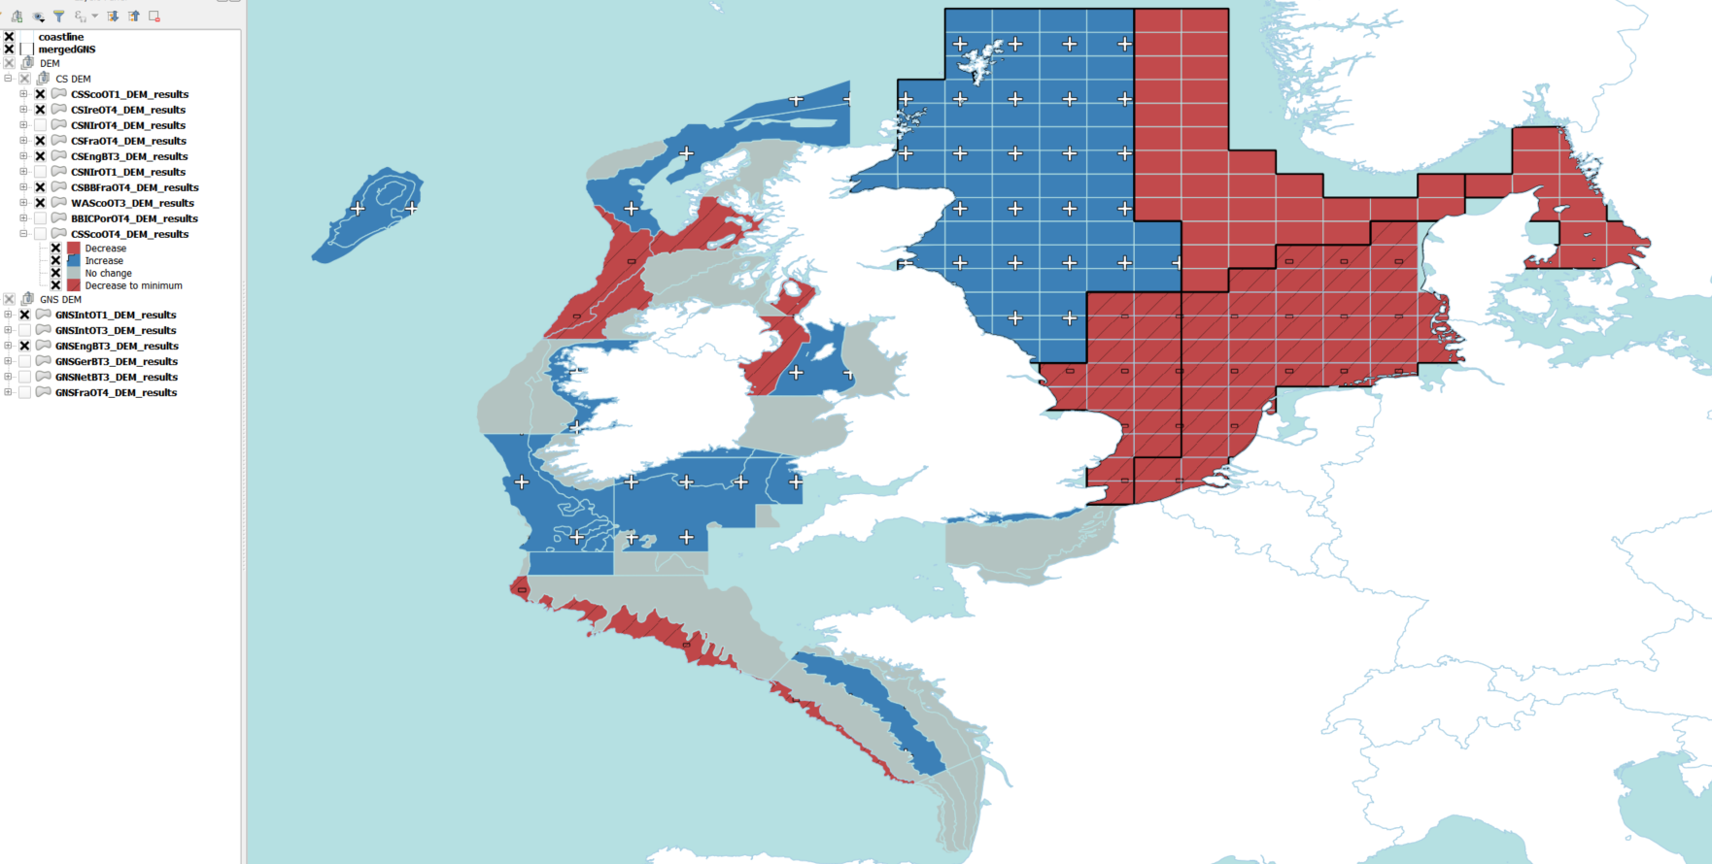

As per figure 1, by default, Figure 2 should also always be output to the user if they have requested the tool to map value results (Boolean = y) and both regions have been selected (Celtic Sea and Atlantic or North Sea surveys). Again the colour scheme is similar to the current colour scheme scheme used for the LFI indicator in the CEFMAT tool, however a more aesthetically pleasing colour-blind friendly colour scheme could also be considered if this is keeping in theme with other fish stock assessments. The shapefiles for this figure are the same as those used for figure 1, but require colouring by a numerical field named from 1980-2017 where the column name indicates the year, and the contents of the attribute table are the value of the LFI in that year. The projection and default plotting order should be the same as that used in figure 1 and again the user should be able to modify this, with the latest full year of results displayed by default (we choose to show results from 2016 as these are spatially complete). It should be clear to the user which year is being displayed, and if possible the user should be able to change the year being displayed with a slider or a button that cycles through the years in the shapefile.

The QGIS file used to present figure 1 can be found in LFI/Colour scheme LFI_Values.qgs

The figure should also be plotted with a colourbar (ideally with the index category intervals given below).

Figure 2: Spatial value of Large Fish Index for key surveys

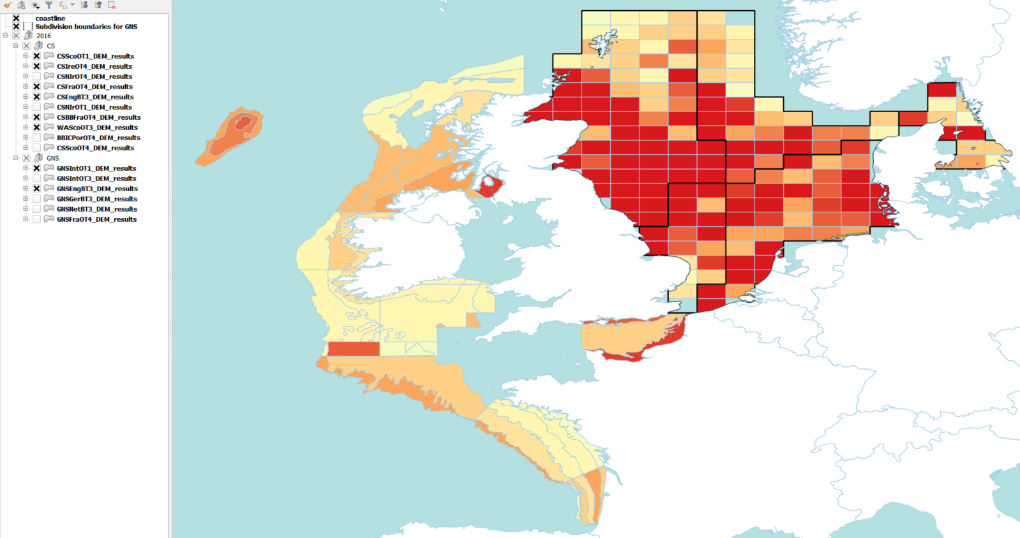

**Produce time series figures by survey (extended results)**: **Graphical outputs**

Time series plots should be output in an “extended results” tab in the CEFMAT tool.

Figures (graphs) in the style of figure s should always be output to the user if they have requested the tool to produce graphical results (Boolean = y) and the relevant region has been selected (Celtic Sea and Atlantic or North Sea surveys / both).

They are produced as BMP files in the format SURVEY_DEM_LFI_LVL2017.bmp, for example CSScoOT1_DEM_LFI_LVL2017. The values used to produce the graphs are also provided by subregion as output .csv files with the suffix “__plotvals”, where the column Year is the x axis, and the y axis data for the various components are given by the columns: “Index_val” “Min_Line” “Upper_bound” “Lower_bound “ ”loessline”.

The results from the breakpoint analysis should also be plotted on figure s. Again these can be found in a separate file as per the _plotvals.csv, but with the suffix “__breakpoint.csv” and should be plotted with a dashed line given by the X and Y values of year_X and Breakpoint_Y, and the colour of column ‘Colour’.

Figure s demonstrates the style that time series figures by survey should be plotted. The label for the different sub-divisions is given above the subplot, and the subplot labelled ‘sea’ is a time series of the aggregated survey data. Each mini-heading shows the p value for the supremum F test which demonstrates whether a significant long-term change is evident (the changes are shown by red dashed lines if significant, or a grey dashed line is used to show a mean level for the whole time series). Annual estimates are shown by blue circles with a fitted LOESS smooth plot (black line) with an estimate of spread shown (± 1 standard deviation). The solid horizontal blue line shows the minimum observed data point prior to the most recent six data points/years and two horizontal thin black lines showing the average indicator value for the first and last six years.

Where graphs or tables are output, these should be accompanied by basic maps that indicate where each subregion is, to put them in a spatial context. An example of these maps is provided in figure c below these graphs, in the table outputs section.

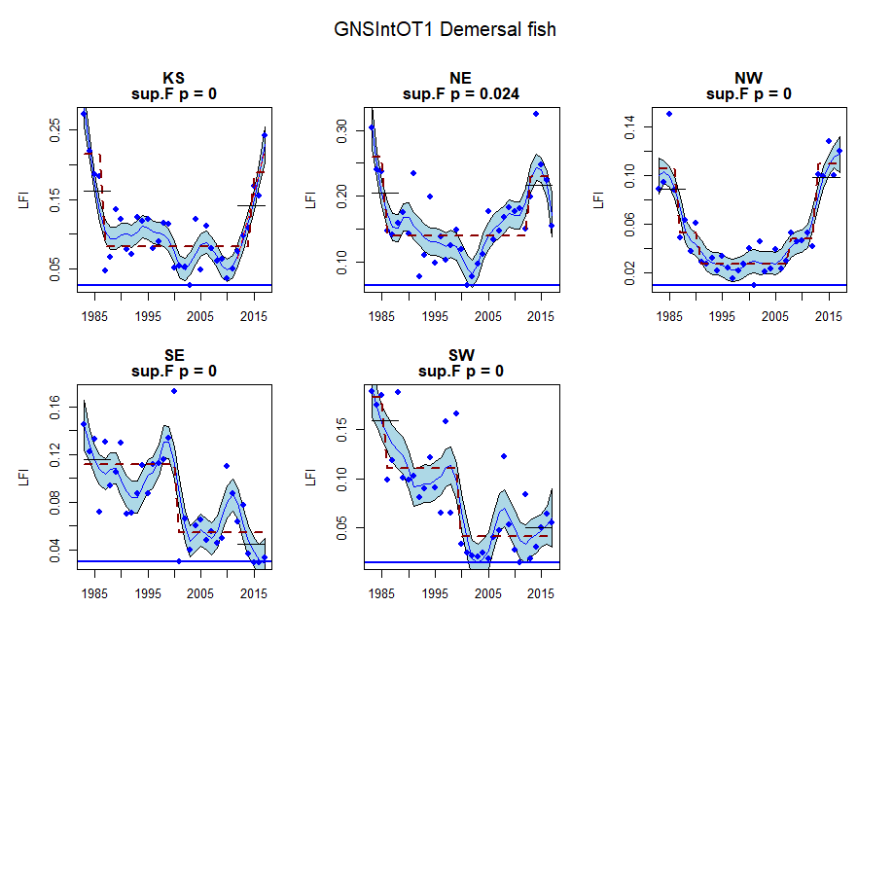

Figure s: Time series of LFI for each sub-division output from the GNSIntOT1 survey

**Table outputs**

Tables should be output in an “extended results” tab, alongside any other survey-specific detailed outputs that the user has requested. For example if the user has chosen all of the following options, the outputs should be generated together, presented survey-by survey:

• Produce time series figures by survey. Extended results, (Boolean=y).

• Produce time series tables by survey. Extended results, (Boolean=y).

• Produce table output of the number of samples used in each assessment. Extended results, (Boolean=y).

Table 2 is an example of the **results** tables that we need to produce using the CEFMAT tool. Tables in this format should always be output to the user if they have requested the tool to produce time series tables by survey, and the relevant region has been selected (Celtic Sea and Atlantic or North Sea surveys / both).

In the caption it should be made clear to the user which of the following inputs the table belongs to:

* Survey (acronym) and sub-region
* Time period that the user has requested to assess

By running the script these tables will be output into the folder LFI/Outputs, and are given in three formats – one where the results are aggregated for the entire survey area, one where they are averaged by subregion, and another where they are averaged by sample stratum (a finer resolution). The format of the names is as so:

SURVEY_DATEDEM_DEM _LFI_sea.csv

SURVEY_DATEDEM_DEM _LFI_subregional.csv

SURVEY_DATEDEM_DEM _LFI_sampstrat.csv

For example for the CSFraOT4 survey, if the script is run on the 9th April 2018, the LFI is given in the tables

CSFraOT4_09Apr2018DEM_DEM _LFI_sea.csv

CSFraOT4_09Apr2018DEM_DEM _LFI_subregional.csv

CSFraOT4_09Apr2018DEM_DEM _LFI_sampstrat.csv (not used)

In order to create the last column in table 2 (“sea”), the results for each region in the subregional.csv are combined with the weighted average in the sea.csv. The sampstrat.csv will not need to be used for this tool.

These tables should be formatted as per Table 2. For example if the user has selected the Celtic Sea, table 2 should be output alongside the tables for CSEngBT3, CSIreOT4, CSNIrOT1, CSNIrOT4, CSScoOT1, CSScoOT4 and WAScoOT3.

Table 2: LFI Metrics (cm) for Pelagic fish estimated from the CSFraOT4 survey between years 1997 and 2015. Columns are given for each subregion (Cc3e, etc) and for the whole survey region (sea). Data should be mapped based on the contents of the column for each subregion.

|  |  |  |  |  |  |  |  |  |  |
| --- | --- | --- | --- | --- | --- | --- | --- | --- | --- |
|  | **Survey Region** | | | | | | | | |
|  | **Cc3e** | **Cc4e** | **Cc4w** | **Cc5** | **Cn2** | **Cn3** | **Cs4** | **Cs5** | **Sea** |
| **1997** | 0.54 | 0.15 | 0.27 | 0.01 | 0.12 | 0.15 | 0.20 | 0.04 | 0.16 |
| **1998** | 0.48 | 0.54 | 0.15 | 0.07 | 0.10 | 0.23 | 0.21 | 0.16 | 0.21 |
| **1999** | 0.33 | 0.51 | 0.09 | 0.09 | 0.10 | 0.05 | 0.34 | 0.20 | 0.15 |
| **2000** | 0.19 | 0.66 | 0.03 | 0.32 | 0.02 | 0.12 | 0.06 | 0.16 | 0.09 |
| **2001** | 0.15 | 0.48 | 0.11 | 0.05 | 0.08 | 0.09 | 0.12 | 0.22 | 0.13 |
| **2002** | 0.20 | 0.56 | 0.07 | 0.03 | 0.12 | 0.23 | 0.18 | 0.25 | 0.17 |
| **2003** | 0.56 | 0.59 | 0.10 | 0.04 | 0.11 | 0.05 | 0.19 | 0.19 | 0.13 |
| **2004** | 0.45 | 0.35 | 0.15 | 0.20 | 0.15 | 0.14 | 0.16 | 0.19 | 0.17 |
| **2005** | 0.17 | 0.47 | 0.26 | 0.16 | 0.11 | 0.24 | 0.22 | 0.28 | 0.22 |
| **2006** | 0.35 | 0.63 | 0.12 | 0.07 | 0.30 | 0.45 | 0.52 | 0.08 | 0.36 |
| **2007** | 0.52 | 0.66 | 0.08 | 0.08 | 0.19 | 0.12 | 0.15 | 0.24 | 0.18 |
| **2008** | 0.34 | 0.53 | 0.03 | 0.08 | 0.16 | 0.15 | 0.08 | 0.23 | 0.11 |
| **2009** | 0.44 | 0.45 | 0.12 | 0.02 | 0.14 | 0.24 | 0.19 | 0.14 | 0.21 |
| **2010** | 0.27 | 0.28 | 0.07 | 0.07 | 0.06 | 0.21 | 0.15 | 0.10 | 0.17 |
| **2011** | 0.30 | 0.56 | 0.16 | 0.21 | 0.14 | 0.11 | 0.27 | 0.07 | 0.14 |
| **2012** | 0.46 | 0.33 | 0.19 | 0.03 | 0.23 | 0.28 | 0.36 | 0.08 | 0.26 |
| **2013** | 0.66 | 0.76 | 0.36 | 0.02 | 0.21 | 0.12 | 0.16 | 0.11 | 0.15 |
| **2014** | 0.34 | 0.67 | 0.31 | 0.11 | 0.14 | 0.08 | 0.32 | 0.14 | 0.19 |
| **2015** | 0.47 | 0.41 | 0.39 | 0.20 | 0.20 | 0.19 | 0.08 | 0.14 | 0.16 |

**Number of hauls tables**

Tables in the style of table b should only be presented if the user has requested to produce table output of the number of samples used in each assessment; extended results (Boolean =y). As stated in the previous section, these outputs should be presented in an extended results section to be found separate to the main map results, as they will be the output of least interest to users. As in the previous section, the table should be matched to the appropriate map that puts the information for each subregion in a spatial context.

If the user has requested Table output of the number of samples used in each assessment, the files for this output are found in the Outputs folder with the prefix of Survey and Date and the suffix “_numhaulsBYsubdiv.csv”.

These tables should be output in the format of table b.

|  |  |  |  |  |  |
| --- | --- | --- | --- | --- | --- |
| Table b: Number of hauls (samples) from in the GNSIntOT1 survey generating data used in the assessment | | | | | |
| **Year** | **KS** | **NE** | **NW** | **SE** | **SW** |
| 1983 | 29 | 57 | 115 | 140 | 35 |
| 1984 | 30 | 79 | 145 | 159 | 40 |
| 1985 | 26 | 82 | 171 | 182 | 50 |
| 1986 | 34 | 82 | 160 | 201 | 45 |
| 1987 | 36 | 86 | 175 | 190 | 44 |
| 1988 | 30 | 79 | 145 | 111 | 36 |
| 1989 | 38 | 80 | 126 | 147 | 33 |
| 1990 | 36 | 80 | 133 | 98 | 29 |
| 1991 | 32 | 95 | 137 | 120 | 37 |
| 1992 | 37 | 71 | 121 | 77 | 32 |
| 1993 | 35 | 70 | 121 | 109 | 32 |
| 1994 | 38 | 71 | 129 | 81 | 38 |
| 1995 | 39 | 71 | 113 | 76 | 33 |
| 1996 | 40 | 62 | 123 | 69 | 30 |
| 1997 | 37 | 73 | 120 | 88 | 36 |
| 1998 | 36 | 71 | 134 | 115 | 40 |
| 1999 | 37 | 69 | 124 | 85 | 36 |
| 2000 | 36 | 76 | 129 | 100 | 36 |
| 2001 | 37 | 68 | 138 | 127 | 52 |
| 2002 | 38 | 72 | 144 | 108 | 50 |
| 2003 | 37 | 68 | 147 | 101 | 53 |
| 2004 | 37 | 66 | 132 | 92 | 40 |
| 2005 | 37 | 72 | 136 | 95 | 42 |
| 2006 | 37 | 64 | 139 | 96 | 38 |
| 2007 | 37 | 61 | 122 | 91 | 37 |
| 2008 | 37 | 67 | 129 | 98 | 33 |
| 2009 | 37 | 70 | 129 | 97 | 36 |
| 2010 | 36 | 66 | 136 | 99 | 38 |
| 2011 | 34 | 64 | 130 | 99 | 38 |
| 2012 | 37 | 64 | 131 | 88 | 37 |
| 2013 | 37 | 63 | 129 | 86 | 38 |
| 2014 | 34 | 43 | 111 | 81 | 36 |
| 2015 | 37 | 59 | 131 | 82 | 40 |
| 2016 | 37 | 62 | 121 | 79 | 35 |
| 2017 | 36 | 65 | 128 | 81 | 34 |

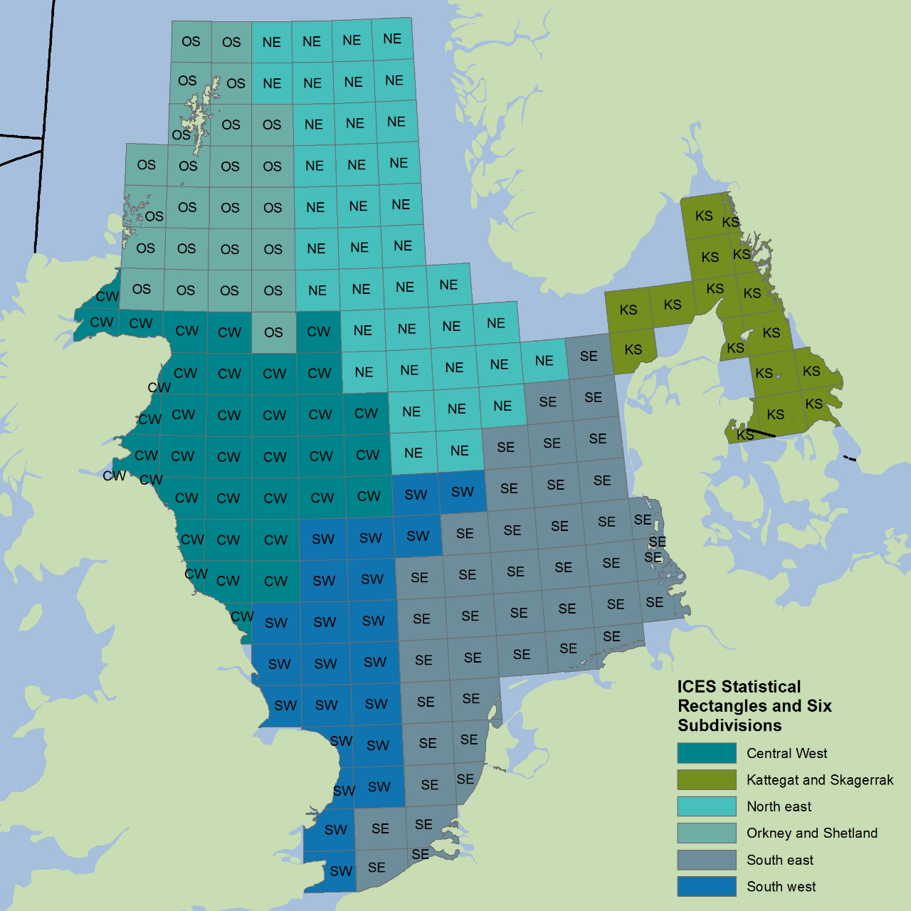Table outputs and graphical outputs should be accompanied by a figure depicting the region to which they relate. Figure c is given as an example.

Figure c: Greater North Sea surveys with rectangular grids and sub-divisions used (note only GNSIntOT1 and GNSIntOT3 cover every sub-division appropriately)

The shapefiles for this figure should be output in LFI\Outputs\ with the format SURVEY_SPECIES_results.shp (the same shapefiles used for map results, simply used instead for the labelling of regions). Alternatively shapefiles can also be found in the location specified in table 1 to produce figures like figure c.

### Performance

### Deliverables

### Acceptance Criteria

Demonstrate functionality and performance described above and as material provided references.

**References**

**Data references:**

Greenstreet, S.P.R and Moriarty, M. (2017) Manual for Version 3 of the Groundfish Survey Monitoring and Assessment Data Product. Scottish Marine and Freshwater Science Vol 8 No 18, 77pp. DOI: 10.7489/1986-1

ICES DATRAS Database. Copenhagen, Denmark. ICES. [accessed Oct 2017]. Downloadable from https://DATRAS.ices.dk/Data_products/Download/Download_Data_public.aspx;

**Literature references:**

Primary assessment: OSPAR, 2017: Size Composition in Fish Communities. OSPAR Portal Intermediate Assessment.

Barnes et al. (2010) Global patterns in predator–prey size relationships reveal size dependency of trophic transfer efficiency Ecology, 91(1), 222–232

Boudreau P. R., L. M. Dickie (1992) Biomass Spectra of Aquatic Ecosystems in Relation to Fisheries Yield. Canadian Journal of Fisheries and Aquatic Sciences, 1992, 49:1528-1538, 10.1139/f92-169

Commission Regulation (EC) No 665/2008 of 14 July 2008 laying down detailed rules for the application of Council Regulation (EC) No 199/2008 concerning the establishment of a Community framework for the collection, management and use of data in the fisheries sector and support for scientific advice regarding the Common Fisheries Policy, http://data.europa.eu/eli/reg/2008/665/oj

Daufresne M., Lengfellner K. and Sommer U. (2009) Global warming benefits the small in aquatic ecosystems PNAS 106 (31) 12788-12793, doi:10.1073/pnas.0902080106

Fraser, H. M., Greenstreet, S. P. R., and Piet, G. J. 2007. Taking account of catchability in groundfish survey trawls: implications for estimating demersal fish biomass. ICES Journal of Marine Science, 64: 1800–1819

Fung, T., Farnsworth, K. D., Shephard, S., Reid, D. G., and Rossberg, A. G. 2013. Why the size structure of marine communities can require decades to recover from fishing. Marine Ecology Progress Series, 484, 155—171. doi:10.3354/meps10305.

Gibert JP, DeLong JP. 2014 Temperature alters food web body-size structure. Biol. Lett. 10: 20140473. http://dx.doi.org/10.1098/rsbl.2014.0473

ICES, 2014a - Report of the Working Group on the Ecosystem Effects of Fishing Activities (WGECO). ICES Document CM 2014/ACOM:26, Copenhagen, Section 3.4.3 (http://tinyurl.com/p8vwu7d)

ICES. 2014b. Interim Report of the Working Group on Multispecies Assessment Methods (WGSAM), 20–24 October 2014, London, UK. ICES CM 2014/SSGSUE:11

IPCC, 2014: Climate Change 2014: Synthesis Report. Contribution of Working Groups I, II and III to the Fifth Assessment Report of the Intergovernmental Panel on Climate Change [Core Writing Team, R.K. Pachauri and L.A. Meyer (eds.)]. IPCC, Geneva, Switzerland, 151 pp.

Jennings, S., Oliveira, J. A. A. D. and Warr, K. J. (2007), Measurement of body size and abundance in tests of macroecological and food web theory. Journal of Animal Ecology, 76: 72–82. doi:10.1111/j.1365-2656.2006.01180.x

Kerr, S. R. & Dickie, L. M. 2001. The biomass spectrum: a predator– prey theory of aquatic production. New York, NY:Columbia University Press.

Lynam C.P. and A.G. Rossberg. (2017) New univariate characterization of fish community size structure improves precision beyound the Large Fish Indicator. Available: at arXiv:1707.06569

Probst WN, Stelzenmüller V (2015) A benchmarking and assessment framework to operationalise ecological indicators based on time series analysis. Ecological Indicators 55: 94-106, doi:10.1016/j.ecolind.2015.02.035

Reum, J. C. P., Jennings, S. and Hunsicker, M. E. (2015), Implications of scaled δ15N fractionation for community predator–prey body mass ratio estimates in size-structured food webs. J Anim Ecol, 84: 1618–1627. doi:10.1111/1365-2656.12405

Riede, J. O., Brose, U., Ebenman, B., Jacob, U., Thompson, R., Townsend, C. R. and Jonsson, T. (2011), Stepping in Elton’s footprints: a general scaling model for body masses and trophic levels across ecosystems. Ecology Letters, 14: 169–178. doi:10.1111/j.1461-0248.2010.01568.x

Rossberg, A. G., Ishii, R., Amemiya, T. and Itoh, K. (2008). The top-down mechanism for body-mass–abundance scaling. Ecology, 89: 567–580. doi:10.1890/07-0124.1

Rossberg, A. G. (2012). A complete analytic theory for structure and dynamics of populations and communities spanning wide ranges in body size. Advances in Ecological Research, 46, 429-522

Shephard, S., Fung, T., Houle, J. E., Farnsworth, K. D., Reid, D. G., and Rossberg, A. G. 2012. Size-selective fishing drives species composition in the Celtic Sea. ICES Journal of Marine Science, 69: 223–234

Walker, N. D., Maxwell, D. L., Le Quesne, W. J. F., and Jennings, S. (2017) Estimating efficiency of survey and commercial trawl gears from comparisons of catch-ratios. ICES Journal of Marine Science, doi:10.1093/icesjms/fsw250

**FOR COMPLETION BY: Landmark Information Group**

**Annex A: Work Plan** *Details the work plan down to key activities and identifies the staff resource and any additional assets needed for each key activity. Only the relevant phases should be complete.*

|  |  |  |  |  |  |  |
| --- | --- | --- | --- | --- | --- | --- |
| **WBS** | **Activity** | **Duration** | **Start** | **End** | **Effort** | **Resource/Cost** |
| **1** | **Analysis** | | | | | |
| 1.1 |  |  | *e.g. Start +1 day* |  |  |  |
| 1.2 |  |  |  |  |  |  |
| 1.3 |  |  |  |  |  |  |
| **2** | **Design** | | | | | |
| 2.1 |  |  |  |  |  |  |
| 2.2 |  |  |  |  |  |  |
| 2.3 |  |  |  |  |  |  |
| **3** | **Build** | | | | | |
| 3.1 |  |  |  |  |  |  |
| 3.2 |  |  |  |  |  |  |
| 3.3 |  |  |  |  |  |  |
| **4** | **Test** | | | | | |
| 4.1 |  |  |  |  |  |  |
| 4.2 |  |  |  |  |  |  |
| 4.3 |  |  |  |  |  |  |
| **5** | **Implement and Handover** | | | | | |
| 5.1 |  |  |  |  |  |  |
| 5.2 |  |  |  |  |  |  |
| 5.3 |  |  |  |  |  |  |

**Assumptions** *Specify any assumptions which underpin the delivery of the work plan*

The activity plan set out above is built on the following assumptions:



**Dependencies** *Specify any dependencies this work package has on other work package, resources or organisations*



**Activity Plan** *insert Gantt chart*